|  |  |  |  |  |
| --- | --- | --- | --- | --- |
| **National University of Computer and Emerging Sciences, Lahore Campus** | | | | |
| C:\Users\saif\AppData\Local\Microsoft\Windows\Temporary Internet Files\Content.Word\final design.jpg | **Course:** | **Data Structures** | **Course Code:** | **CS-218** |
| **Program:** | **BS (Computer Science)** | **Semester:** | **Spring 2020** |
| **Duration:** | **60 Minutes** | **Total Marks:** | **25** |
| **Paper Date:** | **26th Feb-2020** | **Page(s):** | **3** |
| **Section:** | **All sections** | **Roll No.:** |  |
| **Exam:** | **MIDTERM-1** |  |  |
| **Instruction/Notes:** | * Understanding question is a part of your exam. In case of ambiguity, write your assumptions and answer accordingly * Time management is the key to success | | | |

**Q1: [5]**

Calculate time complexity of the following piece of code by formulating 𝑇(𝑛) and computing Big-O (tight bound).

|  |
| --- |
| **int x=0;**  **for (int i=0; i< N; ++i){**  **for (int j=1; j<= 100; ++j){**  **for (int k=j; k<N; ++k){**  **x=x+i+j+k;**  **}**  **}**  **}** |

$$T\left(n\right)=1+N+100N+\frac{N\left(3N-201\right)}{2}+\frac{N\left(3N-201\right)}{2}$$

$$T\left(n\right)=101N+N\left(3N-201\right)+1$$

$$T\left(n\right)=101N+3N^{2}-201N+1$$

$$T\left(n\right)=3N^{2}-100N+1$$

$$T\left(n\right)=O(N^{2})$$

**Q2: [5]**

Write down code/ pseudocode using stack to determine if an input character string is of the form

$$A ∂ B$$

Where, A and B are substrings in the reverse order. For example, if *A = abc*, and *B = cba* , then abc ∂ cba must return **true**. Else, it must return false.

**Q3:**  **[10]**

Given the following code for a Linked List:

|  |
| --- |
| **class LinkedList {**  **struct Node {**  **int data;**  **Node* next;**  **};**  **Node* head;**  **public:**  **LinkedList() {**  **head = 0;**  **}**  **bool changeHead(int pos) {**  **//Your implementation**  **}**  **};** |

Provide an implementation of the function **changeHead** which changes the head of the Linked List to the required position. After changing the head, the list remains a valid Linked List.

A graphical representation of a Linked List is given below: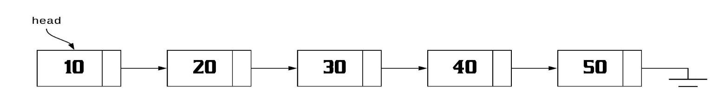

After calling **changeHead(3)** on this list, the resultant Linked List will look something like this: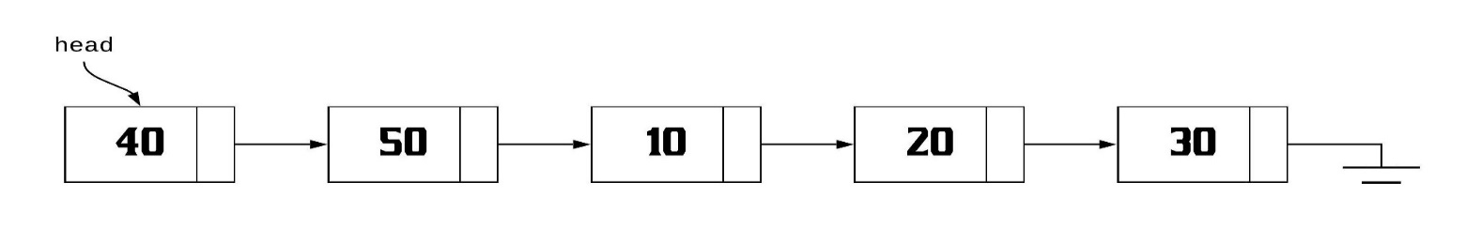

bool changeHead(int pos) {

if (pos < 0) {

return false;

}

if (pos == 0) {

return true;

}

Node* curr = head;

int i = 0;

while (curr && i != pos - 1) {

curr = curr->next;

++i;

}

if (!curr)

return false;

Node* temp = curr;

while (curr->next) {

curr = curr->next;

}

curr->next = head;

head = temp->next;

temp->next = nullptr;

return true;

}

**Q4: [5]**

Consider the following function that takes reference to head of a Doubly Linked List as parameter. Assume that a node of doubly linked list has previous pointer as *prev* and next pointer as *next.* Suppose that reference of head of following Doubly Linked List is passed as an argument to the function

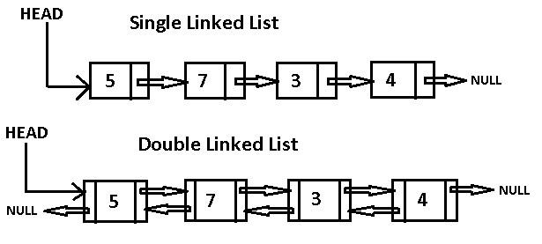

**What will be the output of the function? Draw the modified linked list after the function call?**

**void foo(struct node *&head_ref)**

**{**

**struct node *temp = NULL;**

**struct node *current = head_ref;**

**while (current !=  NULL)**

**{**

**temp = current->prev;**

**current->prev = current->next;**

**current->next = temp;**

**current = current->prev;**

**}**

**if(temp != NULL )**

**head_ref = temp->prev;**

**}**